**Computer Architecture and Assembly Language**

**Home Work- 12**

**NAME:** UROOJ AFRIDI

**COURSE:** COAL - LAB

**Question:**

**Write a program in assembly language that divides the screen into two equal horizontal colors using BIOS services. The colors of the upper and lower halves should be black and magenta respectively. Print star characters in the upper half using loops; first incrementing from one to five and then decrementing from five to one.**

**Moreover, print your FAST ID (Roll No) at the center of the lower half. All the text in the lower half should blink except the FAST ID (Roll No).**

**Code:**

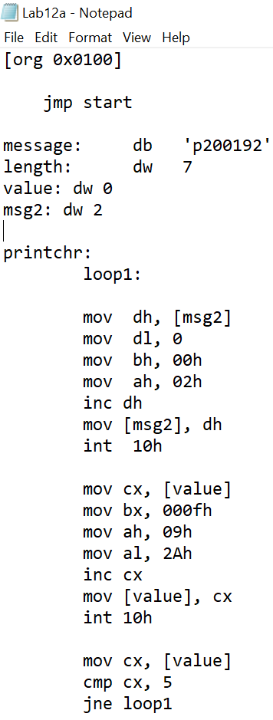 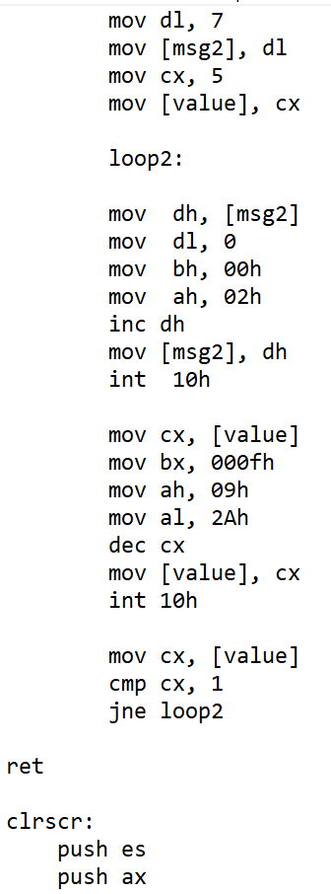

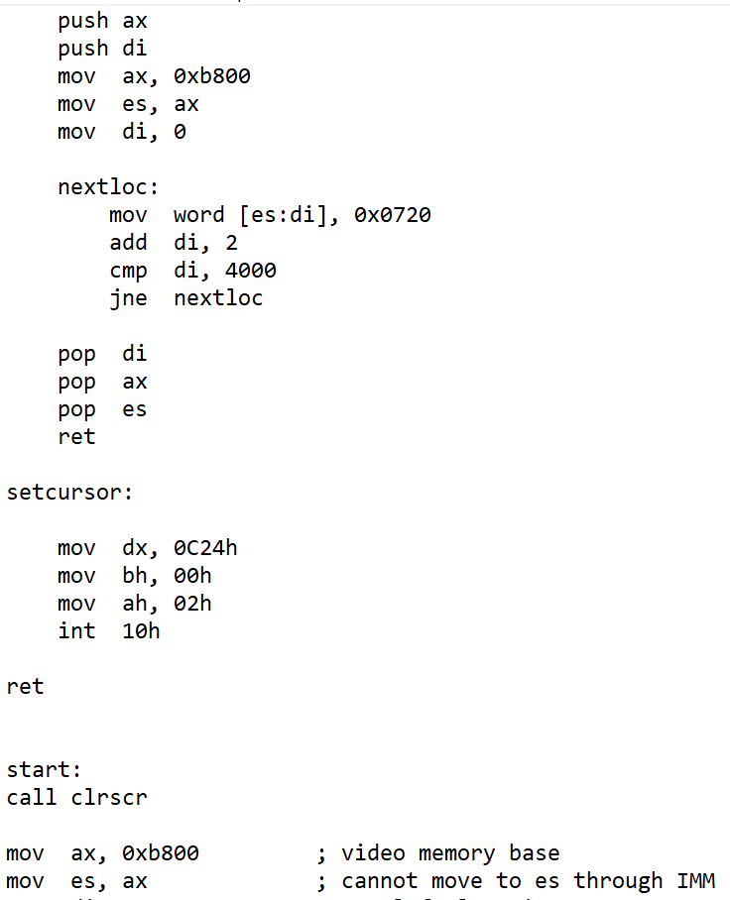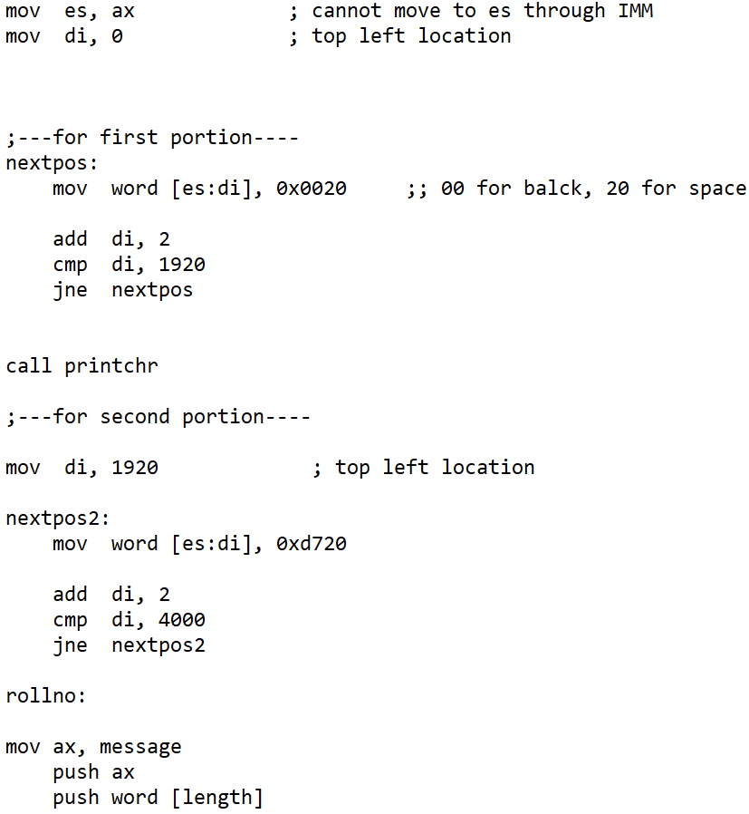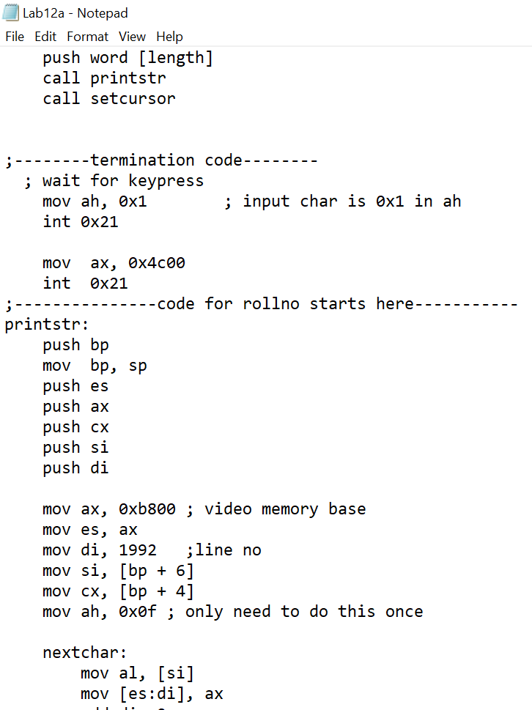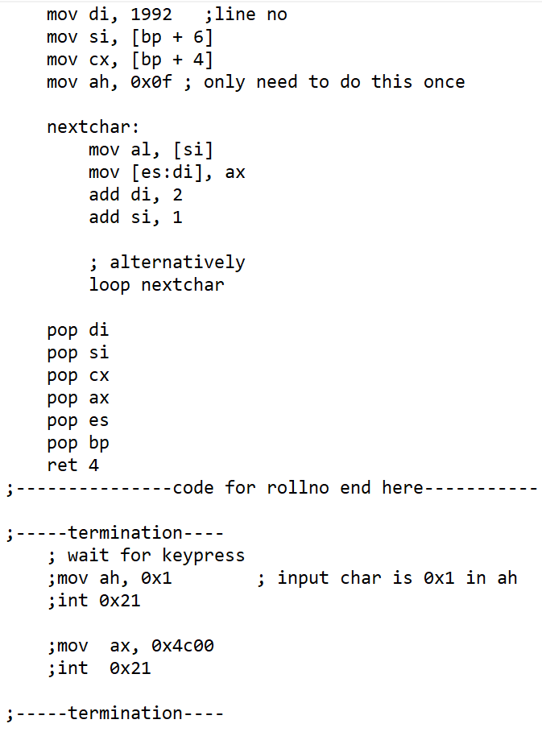

**OUTPUT:**

